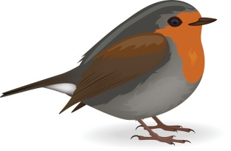
Robin Class Home Learning
This home learning menu has been created to support children’s learning whilst at home. The home learning menu will be updated weekly. These are tasks that our linked to previous or current learning in Robin class that your children will be able to access and enjoy completing. The tasks can be completed in their home learning books. Please encourage your child to choose a few tasks a day to complete to maximise their learning. In addition, just for this week, if your child was in school on Thursday they also have a home learning pack. These completed sheets can be stuck into the home learning books. Please do not hesitate to contact me if you have any questions. Keep working hard, have fun, stay safe and remember I am proud of you!
PSHE and RE:
- Keep a daily diary about your time off school.
- Design a poster to tell people how to wash their hands properly.
- Talk about medicine safety in your home.
- Write a letter or a card to remind someone you know that you are thinking of them at this time.
- If it is safe to do so, could you go out and help someone in need?

Maths:
- Practice adding and taking away using objects in the house i.e. cars, lego etc
- Practice finding ‘half’ of things in your house.
- Use small objects and teddies to practice sharing things out fairly i.e. buttons/grapes. What happens if you try to share 10 things between 3 people? Is it fair?
- Practice telling the time – o’clock times

Phonics:
- Read lots of books!
- Write and draw a picture about your favourite book.
- Practice reading and spelling these words:
he, she, me, be, we, was, you, they, are, all, my
- Practice writing words with the ‘er’ sound at the end – mixer, boxer, dinner, summer, hammer.
- Help to write a shopping list
- Use phonics play to play lots of games to help your reading!

Art:
- Paint/Draw a picture of something you can see out your window.
- Look in a mirror. How carefully can you draw yourself?
- Can you draw a picture of your family?

Science:
- Use your bath or a bowl of water to explore floating and sinking?
What can you find around the house that floats or sinks?

Physical Development:
- Do laps of your garden/street.
- How many star jumps can you do in 2 minutes? What else could you do?
- Go for a nice walk with your family. Maybe take a scooter or bike.
- If you can, go the park or beach!

