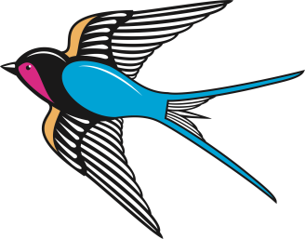
Swallow Class Home Learning
This home learning menu has been created to support children’s learning whilst at home. The home learning menu will be updated weekly. These are tasks that our linked to previous or current learning in Eagle class that your children will be able to access and enjoy completing. The tasks can be completed in their home learning books. Please encourage your child to choose a few tasks a day to complete to maximise their learning. In addition I have sent home Dojo QR codes for parents and children so that we are able to communicate over the coming weeks. I will update this with any resources that I think will support your time at home. Please do not hesitate to contact me if you have any questions. Keep working hard, have fun, stay safe and remember I am proud of you!
Science:
- Design a poster to tell others about classification, inheritance and adaptation and/or light.
- Grow your plant and write daily observations about it. Take photos!
- Make a line graph with the daily measurements of your plant’s height.
- Learn more about different microorganisms.
- Think about different classifications of plants.
English:
- Spellings – list specific ones each week from the year group list (these are on the website) – maximum of 8
- Read lots of books!
- Write a book review about a book you have read recently.
- Write a biography about one of the six wives.
- Write a fantasy story, think about our toolkit.
- Create a fact file abut an animal or person throughout history.
- Write a letter to a loved one.
- Write a letter to the queen about refugees.
Maths:
- TT Rock Stars
- Design and make a times tables game.
- Add the total of the weekly shopping list or some work around money.
- Write some word problems and ask a family member to solve them.
- Practice telling the time.
- Keep an eye on Class Dojo for activities. I will upload work that involves the four operations, shape and space, statistics as well as some daily problems.

PSHE and RE:
- Create an internet safety poster.
- Draw a picture of yourself and write your aspirations.
- Design a poster or write instructions to tell people how to wash their hands.
- Keep a daily diary about your time off school.
- Write a prayer for the world at this time.
- Design a poster for our school Gospel values. How do you show them?

Art and Humanities:
- Create your own portrait of a monarch.
- Use an artist to help you get some ideas for your own artwork.
- Create a picture of you reading your favourite book somewhere extraordinary.
- Paint/Draw a picture of something you can see out your window.
- Draw a picture of the setting from your favourite book.

